The Woodbridge Land Trust

P.O. Box 3699
Woodbridge, CT 06525

Established 1964
woodbridgelandtrust@gmail.com woodbridgelandtrust.org

_______________________________________________________________________________________

Jeff Kaufman August 23, 2014
Chairman
Town Plan & Zoning Commission
Woodbridge, CT 06525

Dear Mr. Kaufman,

I am writing to you on behalf of the Woodbridge Land Trust to share its views and offer suggestions in response to the Woodbridge Town Plan and Zoning Commission’s work to revise the current Plan of Conservation and Development.

1. Discussion of Protected v. Unprotected Open Space.

Open space is an important and central part of Woodbridge’s character. Many people are drawn to and choose to live in Woodbridge because of its open spaces. In numerous referenda, Woodbridge residents have repeatedly affirmed the importance of open space and agriculture by voting to provide the financial resources needed to acquire and protect these important lands. Clearly, residents view open space as a high town priority.

Woodbridge is a first-ring suburb. It occupies 19.2 square miles, or 12,288 acres. In materials provided by the engineering firm Milone and MacBroom earlier this summer, the firm calculated that 33% of Woodbridge is comprised of fields, wooded trails, ball fields, public areas and playgrounds. Based on these calculations, it has identified and has described Woodbridge as “unique” among first-ring suburbs. However, much of Woodbridge’s open space is not protected from future development, and it is unclear whether Woodbridge retains its unique status when unprotected open space is removed from the calculation.

In general, protected open space is defined as open space which is subject to certain restrictions that limit the use and transfer of the property in order to maintain its status for conservation and/or recreation purposes. Land is only fully protected from development when it is owned by organizations and trusts with a specific mandate or mission to protect open space, or through grants of conservation restriction that legally protect the land. In Woodbridge, such lands are held by the Woodbridge Land Trust (149 acres), the
Woodbridge Park Association (132 acres) and the town of Woodbridge (670 acres protected through grants of conservation restriction held by the Woodbridge Land Trust.) Combined, this totals 951 acres, or 7.7% of Woodbridge. (See Map A.)

Additional to these fully protected open spaces, the Regional Water Authority owns land in
Woodbridge designated as three different classes. According to Tim Baird of Milone and MacBroom regarding the water company land in Woodbridge, Class III land could feasibly be sold or repurposed, while both Class I and II are subject to a review process for any change in use or ownership, and any proceeds from a sale or lease must be reinvested in protecting additional land. The state’s Green Plan that guides open space acquisition classifies both Class I and II lands as “protected open space.”

The Regional Water Authority’s Class I and Class II lands in Woodbridge are 1,622 acres. (See Map B showing Class I, II and III lands owned by the Regional Water Authority.) When combining Class I and Class II lands with the land owned and protected by the Woodbridge Land Trust and the Woodbridge Park Association, the total is 2,573 acres, or 21% of Woodbridge.

However, it is important to note that the Regional Water Authority does not have a primary mission to protect open space, that they do have the ability to sell Class I and Class II land as well as Class III land, and if they were required to reinvest proceeds from the sale of Class I and II land, that reinvestment might very well not be in Woodbridge. For this reason, land owned by the Regional Water Authority, whether Class I, II, or III cannot be considered as fully protected.

There are other open space properties owned by the Town of Woodbridge, and entities and institutions such as Connecticut Light & Power, Golf Courses, the Jewish Community Center and churches (See Map C). These tracts are also not protected and could be made available for development. A number of town-owned properties that are not open space (the
Center Building, Transfer Station, Animal Shelter, for example) were included in Milone and MacBroom’s 33% protected open space figure in their materials provided earlier this summer.

Additionally, private citizens own portions of the land identified as open space by Milone and MacBroom, and these parcels could be sold for development. Development of these unprotected parcels individually or collectively would impact the character of the town. (Map D shows some of the larger open space parcels that are owned by private individuals.)

Farmland and farming has drawn increasing attention in recent years, with the growing importance of food security and local healthy food production. Woodbridge has a number of farms which are shown in Map E.

Woodbridge has a system of walking trails which are blazed and maintained, with trail maps available on the town website. A map of trails throughout the town is shown on Map F.

In 1997 the General Assembly set a state goal of acquiring or permanently protecting 21 percent of Connecticut’s land as open space by the year 2023, which Milone and MacBroom referenced in their materials. However, a state-wide goal does not address the percentage of open space that any single town should protect. For towns such as Woodbridge where open space is a central defining element of the town’s character, one might expect that the town would choose to protect more than a state-wide average, and should work through its own planning process to define the open space that it should protect and maintain.

- Value of Protected Open Space.

It is also worth clarifying why open space is worth protecting. Open space provides a host of benefits for our town including the following, where open space:

  - Reduces the tax burden on residents – A study published in 2010 by the New York State Office of the State Comptroller enumerates a number of economic benefits of open space for towns, citing studies that show that adding residential development to towns typically costs the town more in services than the tax revenues gained. In other words, the development of open space has a constraining effect on town budgets, rather than the reverse as some might believe.

Numerous studies demonstrate that on average, communities with more open space have a lower tax burden than communities with more residential development and less open space. It has also been shown that that the services to support residential properties typically cost a town more than the taxes collected from that residential property. For example, a recent American Farmland Trust study found that the median cost to provide public services for different land uses was $1.16 per tax dollar raised for residential land uses—a 16-cent deficit—compared to $0.35 (35 cents) per tax dollar for open space—a 65-cent surplus. Additionally, open space reduces spending on infrastructure – by holding down costs that grow with development such as storm water runoff systems.

  - Improves property values – Studies show that open space enhances local property values, which leads to increased tax revenue. Property values of land close to open space are generally higher than land at a greater distance from open space.

  - Attracts business investment – Open space generally contributes to quality of life, and businesses look for opportunities for their employees that promote quality of life. While Woodbridge does not have a large presence of businesses compared to some other nearby towns, the open-space character of Woodbridge provides one of the benefits that attract business owners to locate their businesses in town. The economist John Crompton said, “The importance of quality of life in business location decisions has been repeatedly verified in the literature . . . . No matter how quality of
life is defined, park and recreational opportunities are likely to be a major component of it.”

  - Protects indigenous species and natural habitats – Woodbridge is home to thousands of species of animals and plants which live in our grasslands, our woodlands and our waterways. Land development removes habitat necessary for many species to thrive. When open space is protected, we also protect and maintain the viability of other life forms, many who were living here before humans arrived.

  - Promotes healthy lifestyles – Open space can be a tool in supporting a healthy lifestyle by providing access to walking and recreational activities. Given the rising cost of healthcare, and the current obesity epidemic, this is one of the high priorities for us to address.

  - Defines the character of the town – Woodbridge’s unique rural and historic character is maintained in large part due to its visible open space which graces the roads and public areas of the town. In many ways this open space makes Woodbridge what it is, brings people to the town, and causes them to stay as long term, committed residents.

  - Provides spiritual and emotional sustenance – It is a common human trait to derive spiritual and emotional inspiration from open space and the natural beauty of the earth. Artists, authors, composers and spiritual leaders have all represented this in their works. When we destroy this beauty, we lose as a culture, when we preserve it we maintain something important and fundamental that carries forward for generations to come.

- Recommendations.

Given that open space provides such benefits to the town, and that much of the town’s open space is not protected or fully protected, we recommend that the Town of Woodbridge, as part of its Town Plan of Conservation and Development adopt the following goals. Overall, these goals aim to maintain the current open space in Woodbridge.

  - Purchase, acquire and protect any land that the Regional Water Authority seeks to divest in the future. This land is prime open space property in the town. (Such properties would be a portion of the land indicated in Map A.)

  - Maintain and further develop our greenway system through the town for walking and
“passive” recreation. Map F shows existing trails in Woodbridge. Roads that connect trails to each other, or possible trails that could be added to make loops are also marked. With additional publicity and signage, and with some modest construction of trails, the greenway trail system in Woodbridge could be further enhanced and continue to be one of the main features of our town.

  - Take a proactive role in helping to preserve farmland in Woodbridge that is unprotected. Several farms are currently protected in Woodbridge, including Massaro Farm (which is owned by the Town and protected by a grant of conservation restriction held by the Woodbridge Land Trust) and Shepherd’s Farm (which is protected through an initiative of the Trust for Public Lands). There are also a number of farmland properties that are privately owned and are currently farmed, such as 902 Baldwin Road, the former Hubbell Farm on Amity Road (particularly vulnerable since it is on a sewer line), or the Kalson property at the corner of Beecher and Center
Road at the middle of town (1795 Beecher Road). (Farmland properties in
Woodbridge are shown on Map E.)

It will be important that the town also maintain the Farmland Preservation Plan which was added in October 2013 as part of the town’s present Open Space Plan. The Farmland Preservation Plan prioritizes the preservation of farms and farmland soils. Having the Farmland Preservation Plan in the town’s Open Space Plan also qualifies Woodbridge for certain state and federal grants to support the preservation of open space and farmland.

  - Consider establishing an Agricultural Commission that would be charged with the promotion of town agriculture and the town's Farmland Preservation Plan, which in turn reinforce town open space and quality of life objectives. Governor Malloy's administration has actively encouraged towns to establish Agriculture Commissions via Connecticut Public Act 11-188, passed in 2011. In 2006, Guilford established Connecticut's first Agriculture Commission. Three years later, in 2009, only 3 Connecticut towns had Agriculture Commissions, but by the end of 2012 that number had grown to more than 20 towns with Agriculture Commissions. According to Joan Nichols, Director of Community Outreach for the Connecticut Farm Bureau
Association, there are currently more than 40 Connecticut towns with an Agriculture Commission or Committee

  - Support the protection of privately owned open space properties that come up for sale by cooperating with grant applications to the Connecticut State Department of Energy and Environmental Protection, the State and Federal Government
Department of Agriculture, or similar public grants, and working with the Woodbridge Land Trust or other similar group who are working to secure the protection of such land. This would not necessarily require any financial commitment from the town, as purchases could be supported through grants or third parties. However, such grant applications often require a letter of support from the town. (Large parcels of privately owned open space to consider for protection are shown in Map D.)

  - Maintain the annual budget line-item of $1 Million for open space purchases, which has been a part of the town’s budget for some time.

  - Support, in concept, the donation of wetlands properties owned by individuals to an organization such as the Woodbridge Land Trust or the Woodbridge Park Association who, by owning such properties, will protect them from possible development. While the Inland Wetlands Commission provides some level of protection, some encroachment into and development of wetlands has occurred over time.

  - Establish grants of conservation restriction on town-owned property of central importance to the town’s rural and historic character, such as the Fitzgerald Property at the center of town.

The Woodbridge Land Trust Board of Directors represents the 490 members of the Trust who support the work of preserving open space in Woodbridge. We put forth these goals furthering a tradition of open space preservation that is shared by many interests. We are in alignment with those federal and state-level agencies who support the protection of open space, such as the United States Department of Agriculture, the Connecticut Department of Energy and Environmental Protection, and others. We join in a tradition of land protection within the town of Woodbridge furthered by prior and present town boards and commissions along the Woodbridge Park Association and Woodbridge Garden Club.

The Woodbridge Land Trust, as an integral member of the groups, commissions and organizations who are attentive to stewardship of Woodbridge’s lands looks forward to working collaboratively with others who also seek to maintain and promote the town’s character through the value that protected open space brings to its residents. We would be happy to respond to any questions you may have, and to participate in sharing our position with the Town Plan & Zoning Commission.

Very truly yours,

Christopher Keevil
President
Woodbridge Land Trust

cc: Leslie Martino, President, Woodbridge Park Association

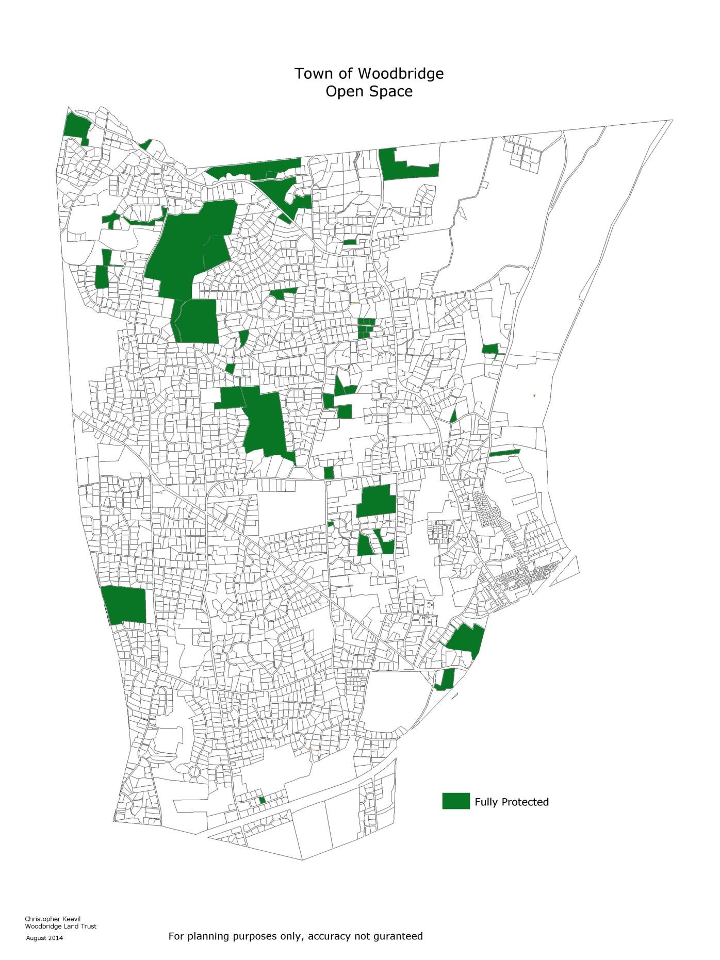
Map A
Open space that is fully protected
Sources: Tax Map Viewer (a website providing property data including ownership and acreage); Milone and MacBroom; the town of
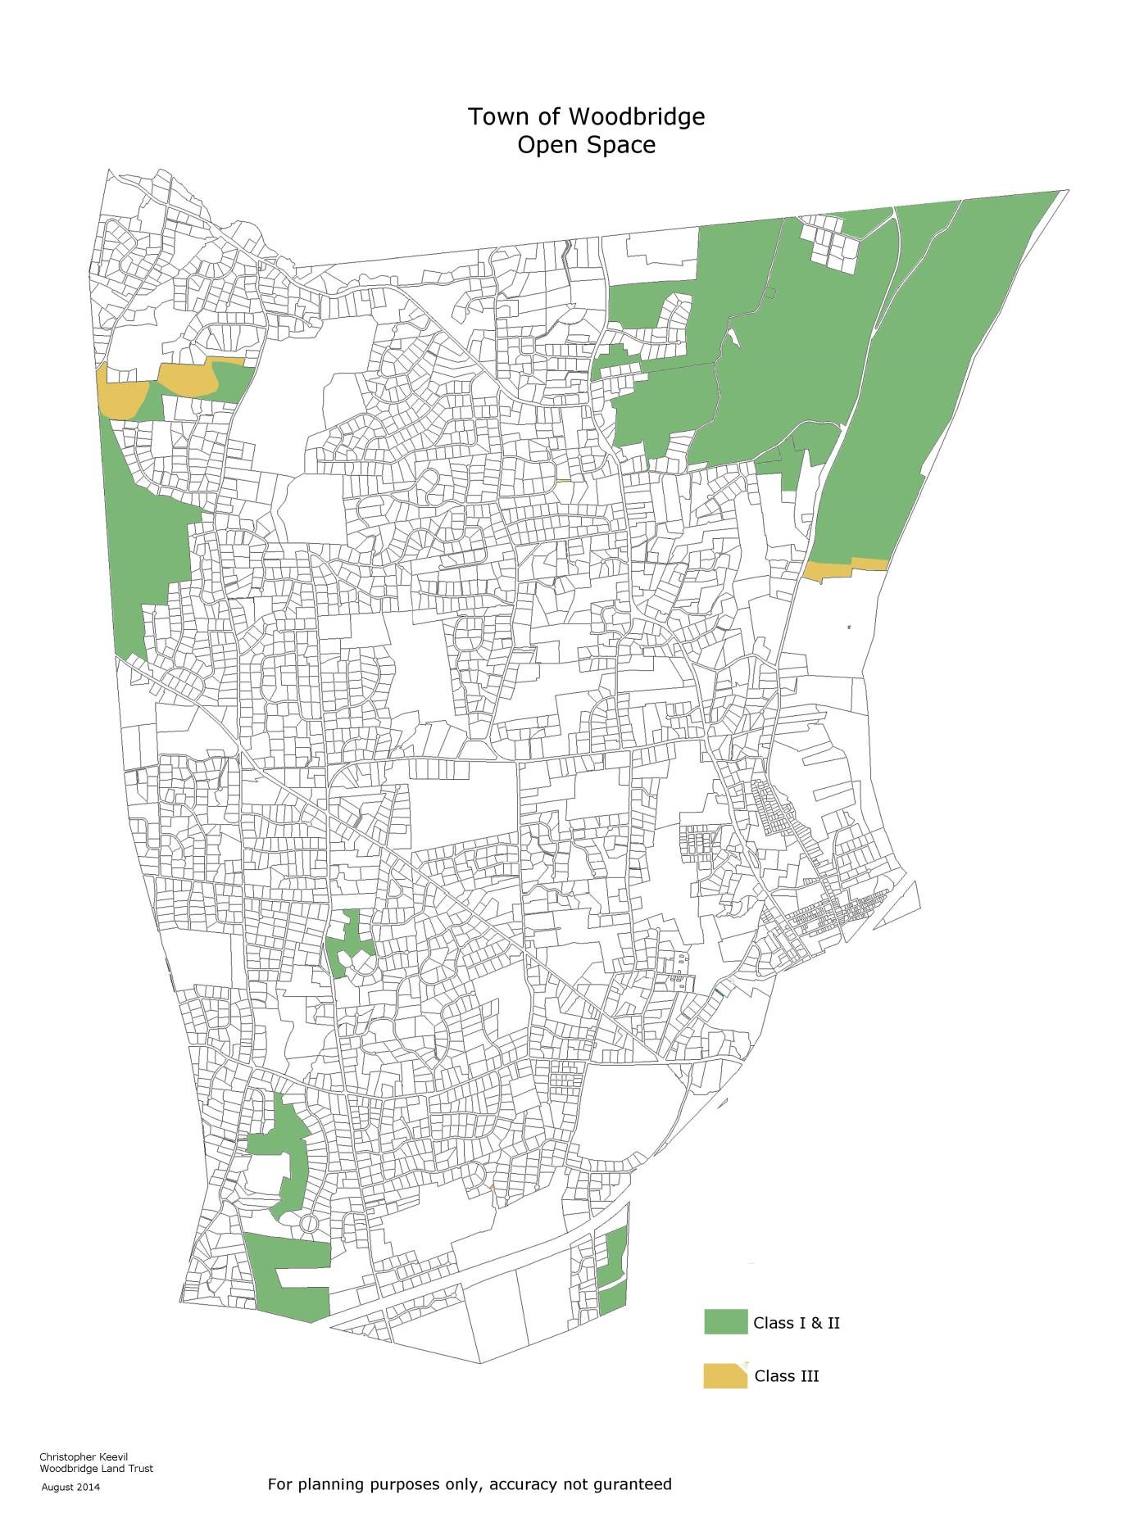
Map B
Open space owned by the Regional Water Authority
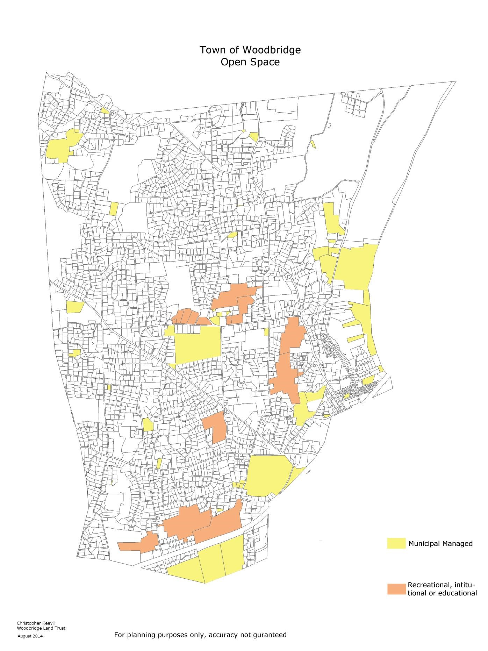
Map C
Municipal and institutional land, not protected

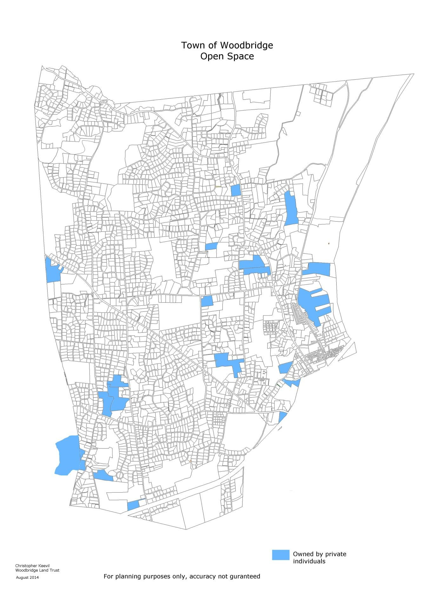
Map D
Some of the larger open space parcels owned by private individuals
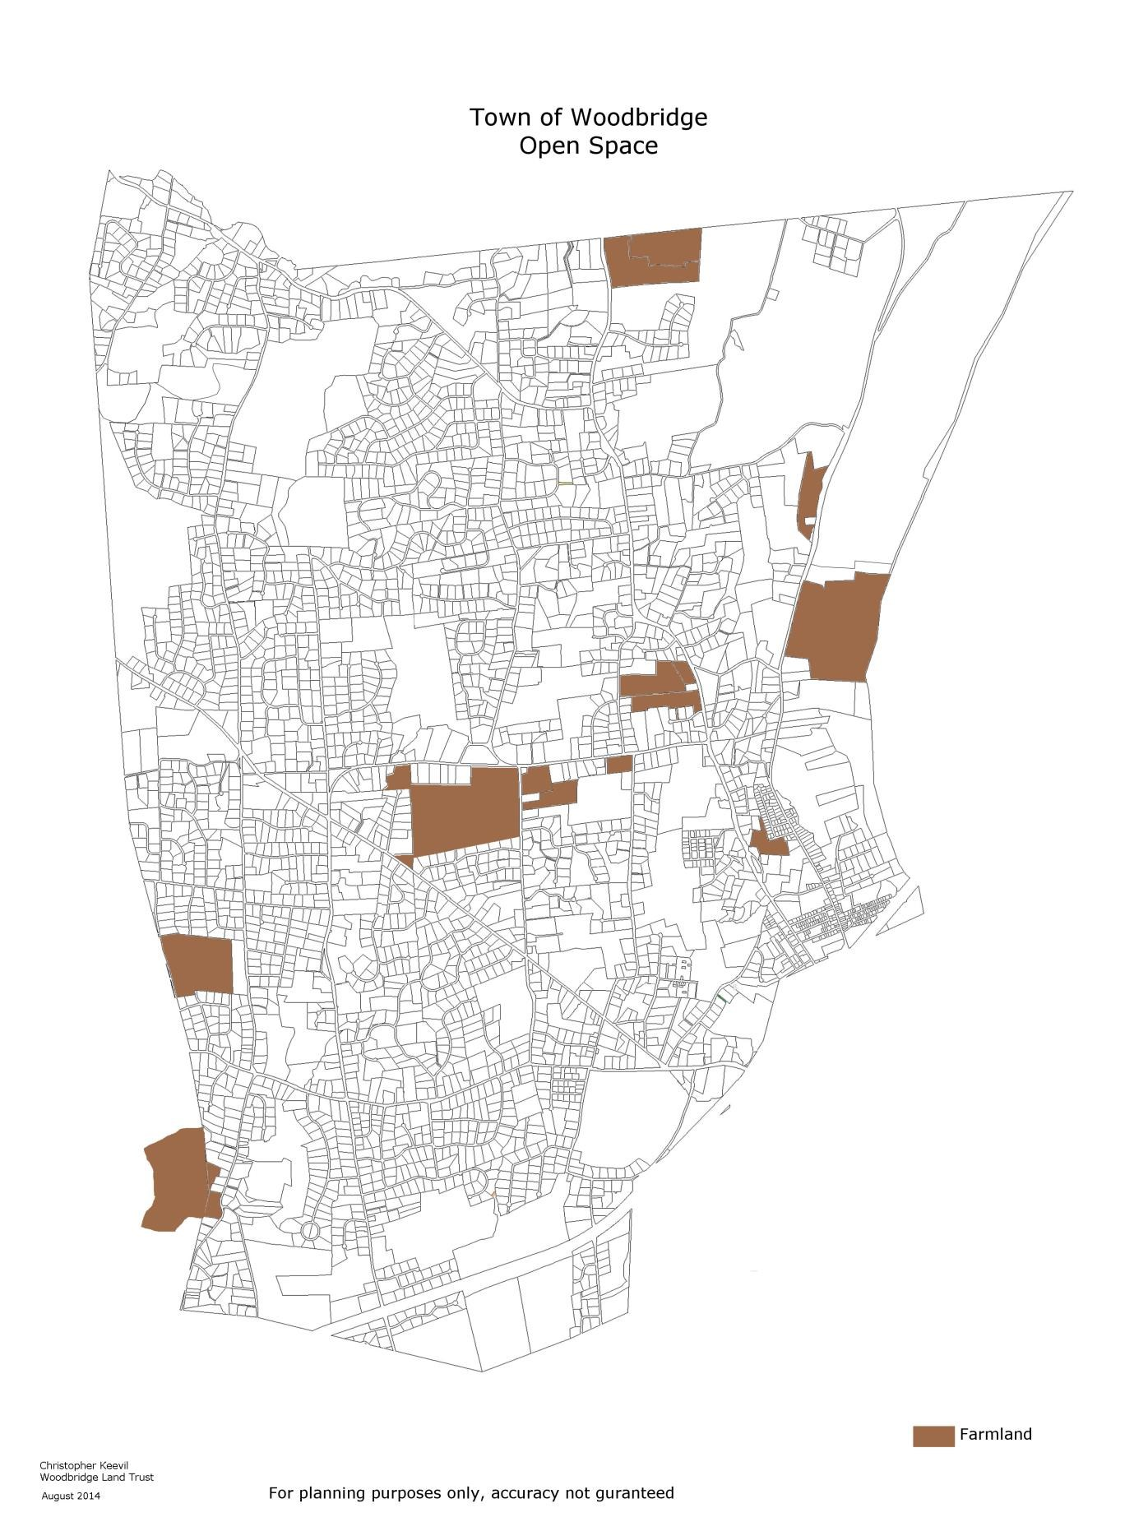
Map E Farmland in Woodbridge
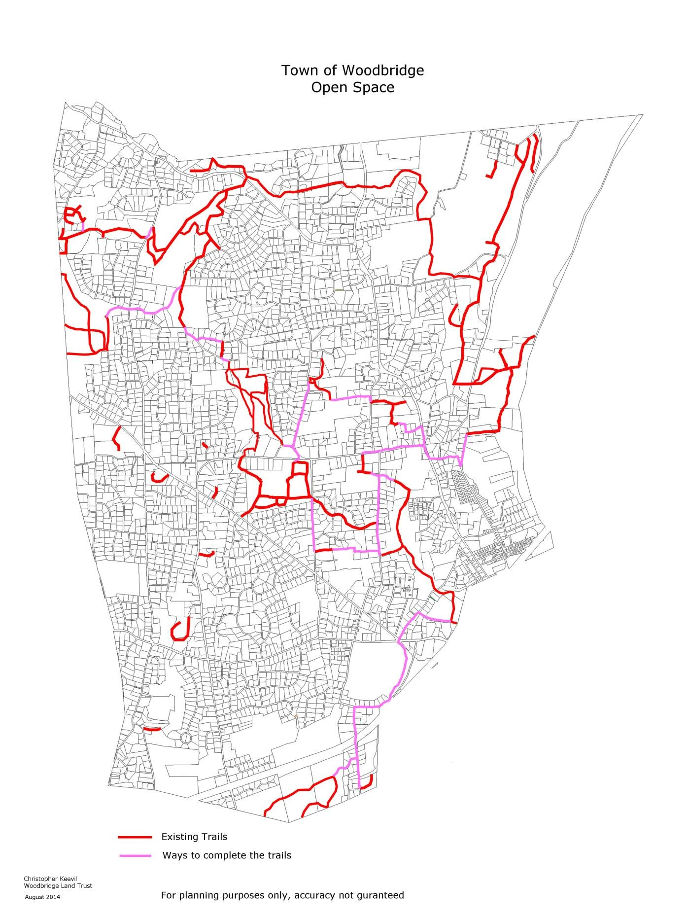
Map F
Existing walking trails, and ways to complete the trails as loops

Office of the New York State Comptroller, Thomas P. DiNapoli, State Comptroller, Economic Benefits of Open Space Preservation March 2010
See e.g., Active Living Research, “The Economic Benefits of Open Space, Recreation Facilities, and Walkable Design,”
; Crompton, J., “Community Benefits and Repositioning: The Keys to Park and Recreation’s Future Viability,” Virginia: National Recreation and Park Association, 2007; American Farmland Trust - Farmland Information Center, “Fact Sheet: Cost of Community Service Studies,” 2010.
American Farmland Trust - Farmland Information Center, “Fact Sheet: Cost of Community Service Studies,” 2010; Land Trust Alliance, Washington D.C.
Crompton, J., “The Impact of Parks and Open Space on Property Taxes,” in Trust for Public Land, The Economic Benefits of Land Conservation, 2007.
Active Living Research, “The Economic Benefits of Open Space, Recreation Facilities, and Walkable Design,” 2010; Crompton, J.,
An actual purchase of open space would still need approval from the townspeople.

